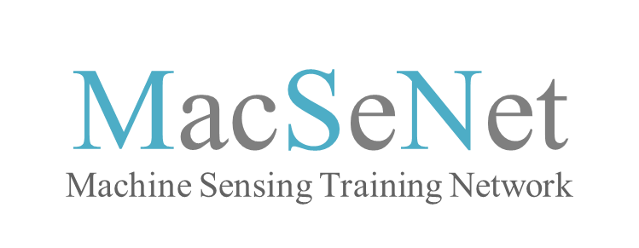

To be eligible for this ITN you should be within four years of the diploma granting you access to doctorate studies at the time of recruitment.
In addition, to be eligible for a position as a Marie Sklodowska-Curie Early Stage Researcher you must not have spent more than 12 months in the host country in the 3 years prior to starting.
Please ensure that the information you provide on this eligibility form is correct as the EU will not fund researchers who do not meet these criteria.

Name of the Candidate:
Email address:
Position applied for (ESR1-18):
Indicate when you would be able to start you role |  | (Date)
ITN eligibility criteria questionnaire

1 | When did you get the diploma entitling you to enter PhD studies? (In Europe, this is generally a Master’s degree) |  | (Day/month/year)
2 | Nationality (if more than one, please provide all)
3 | Have you ever been a resident in the country you are applying for? |  | Yes No
4 | If yes, have you spent more than 12 months in this country over the last 36 months (work, studies, etc?) (Short stays such as holidays are not counted) |  | Yes No
5 | Date of Application

MacSeNet — Machine Sensing Training Network | Project number - 642685
MacSeNet is funded under the H2020-MSCA-ITN-2014 call and is part of the Marie Sklodowska-Curie Actions — Innovative Training Networks (ITN) funding scheme

